Created the cluster
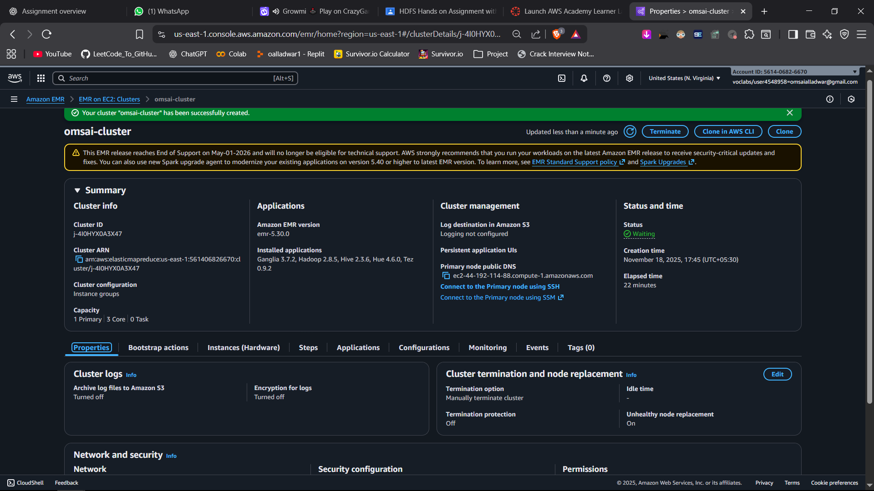

Edited security group to allow all traffic from ipv4 anywhere
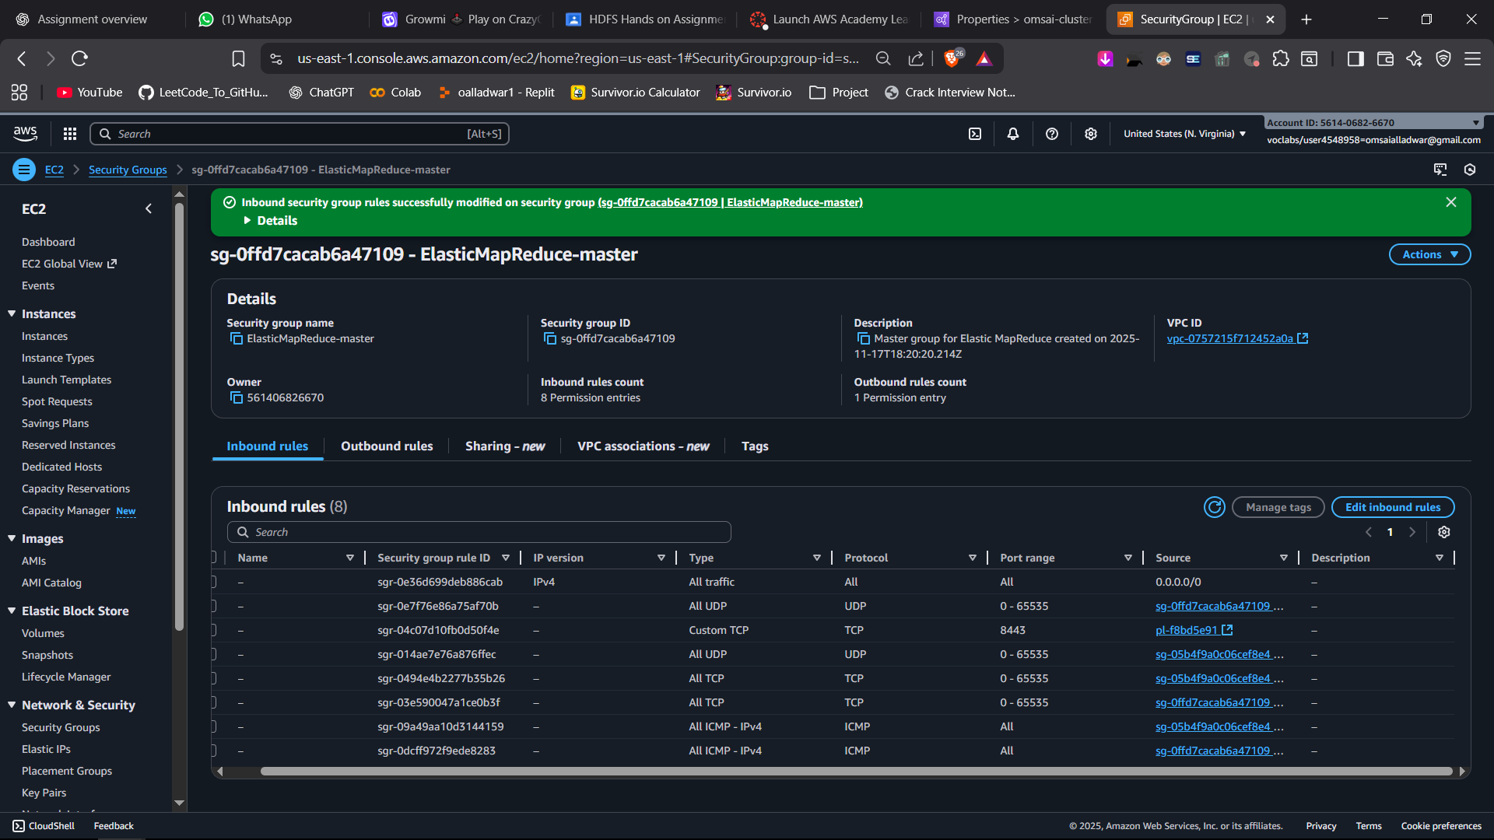

Connected to master using mobaxterm

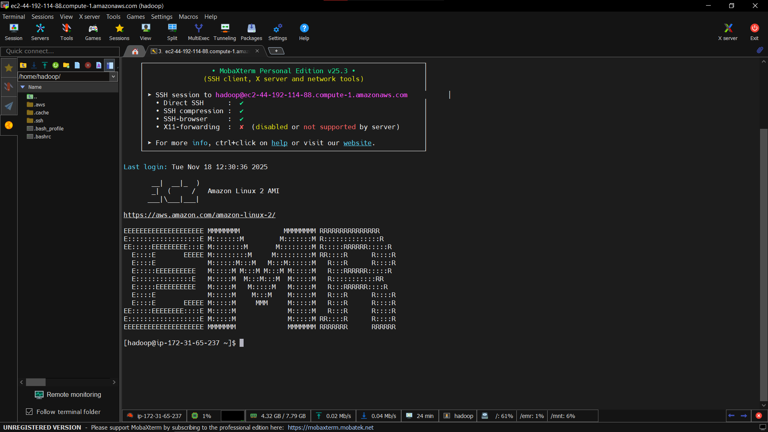

shown master node’s hostname
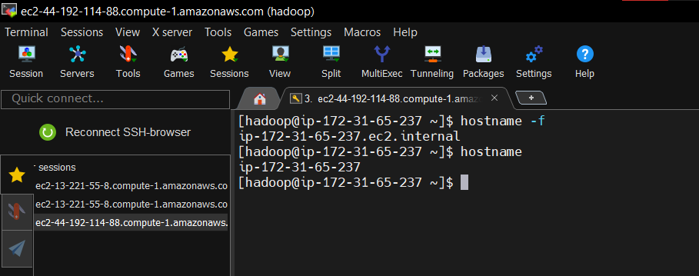

Uploaded sample.txt to the local
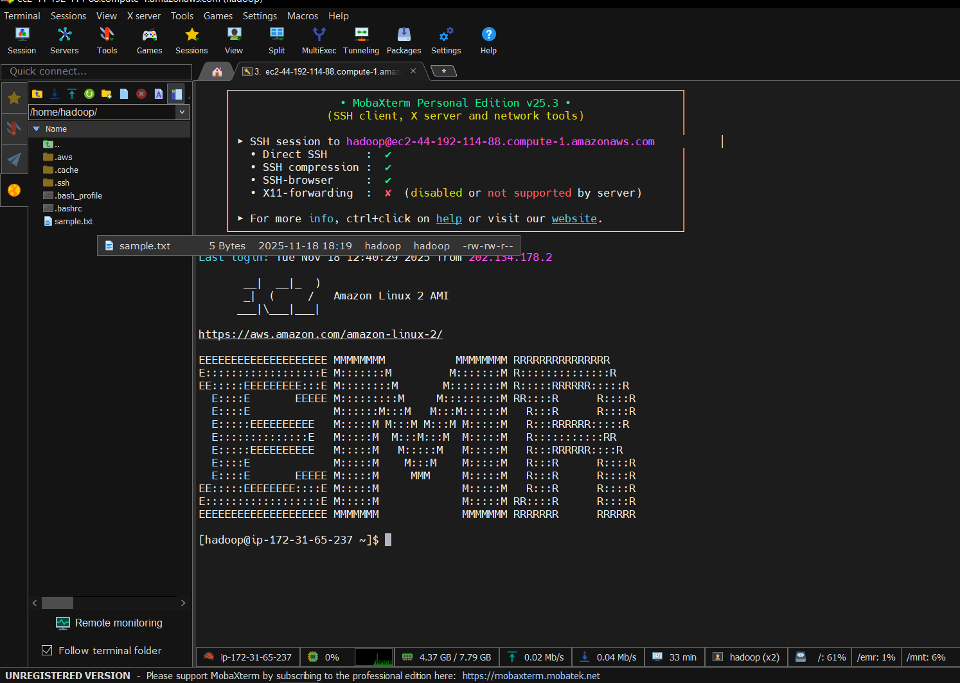

Created test directory in Hadoop root directory
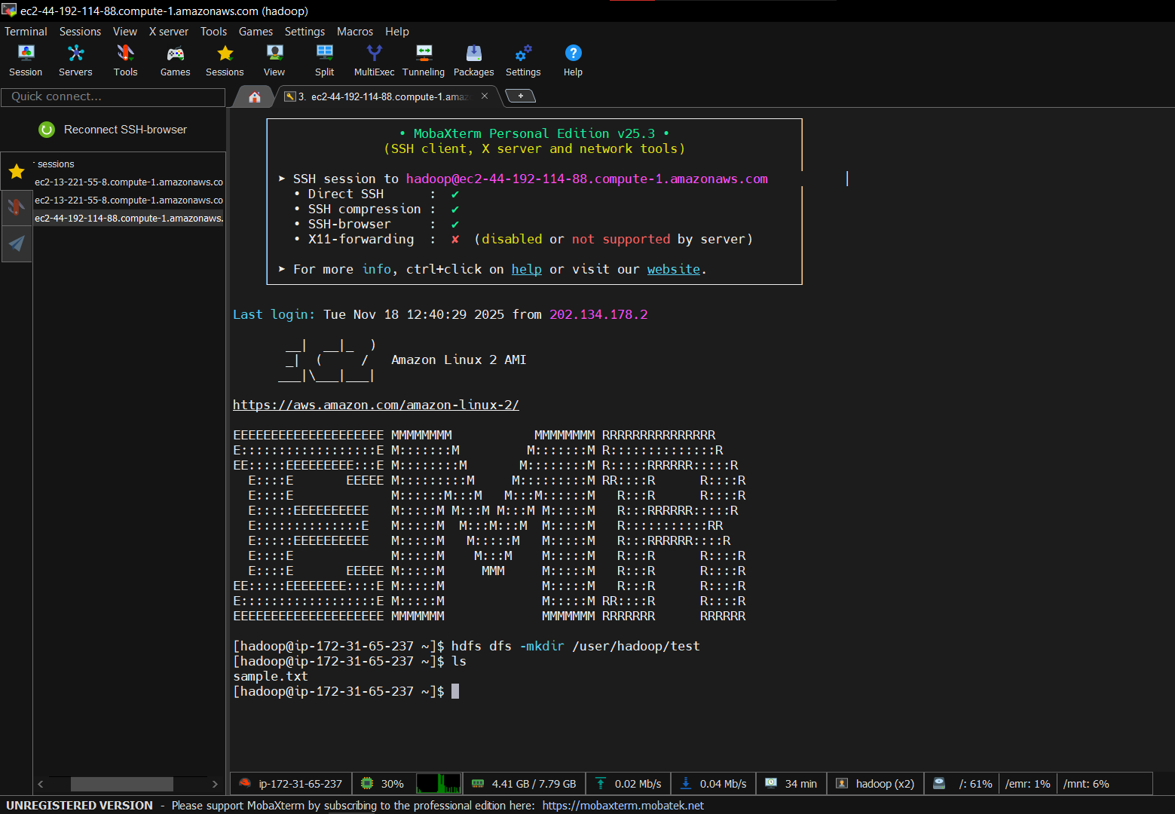

Uploaded sample.txt to /user/Hadoop/test/
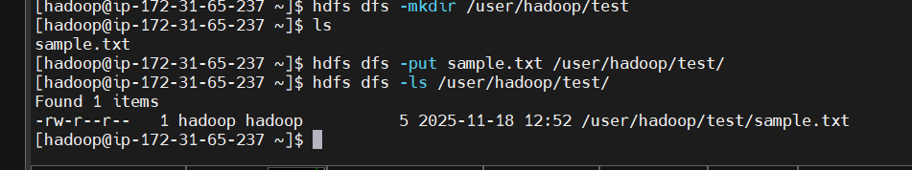

Using Hue, created a new folder new_test, inside it, created test1,test2,test3 folders
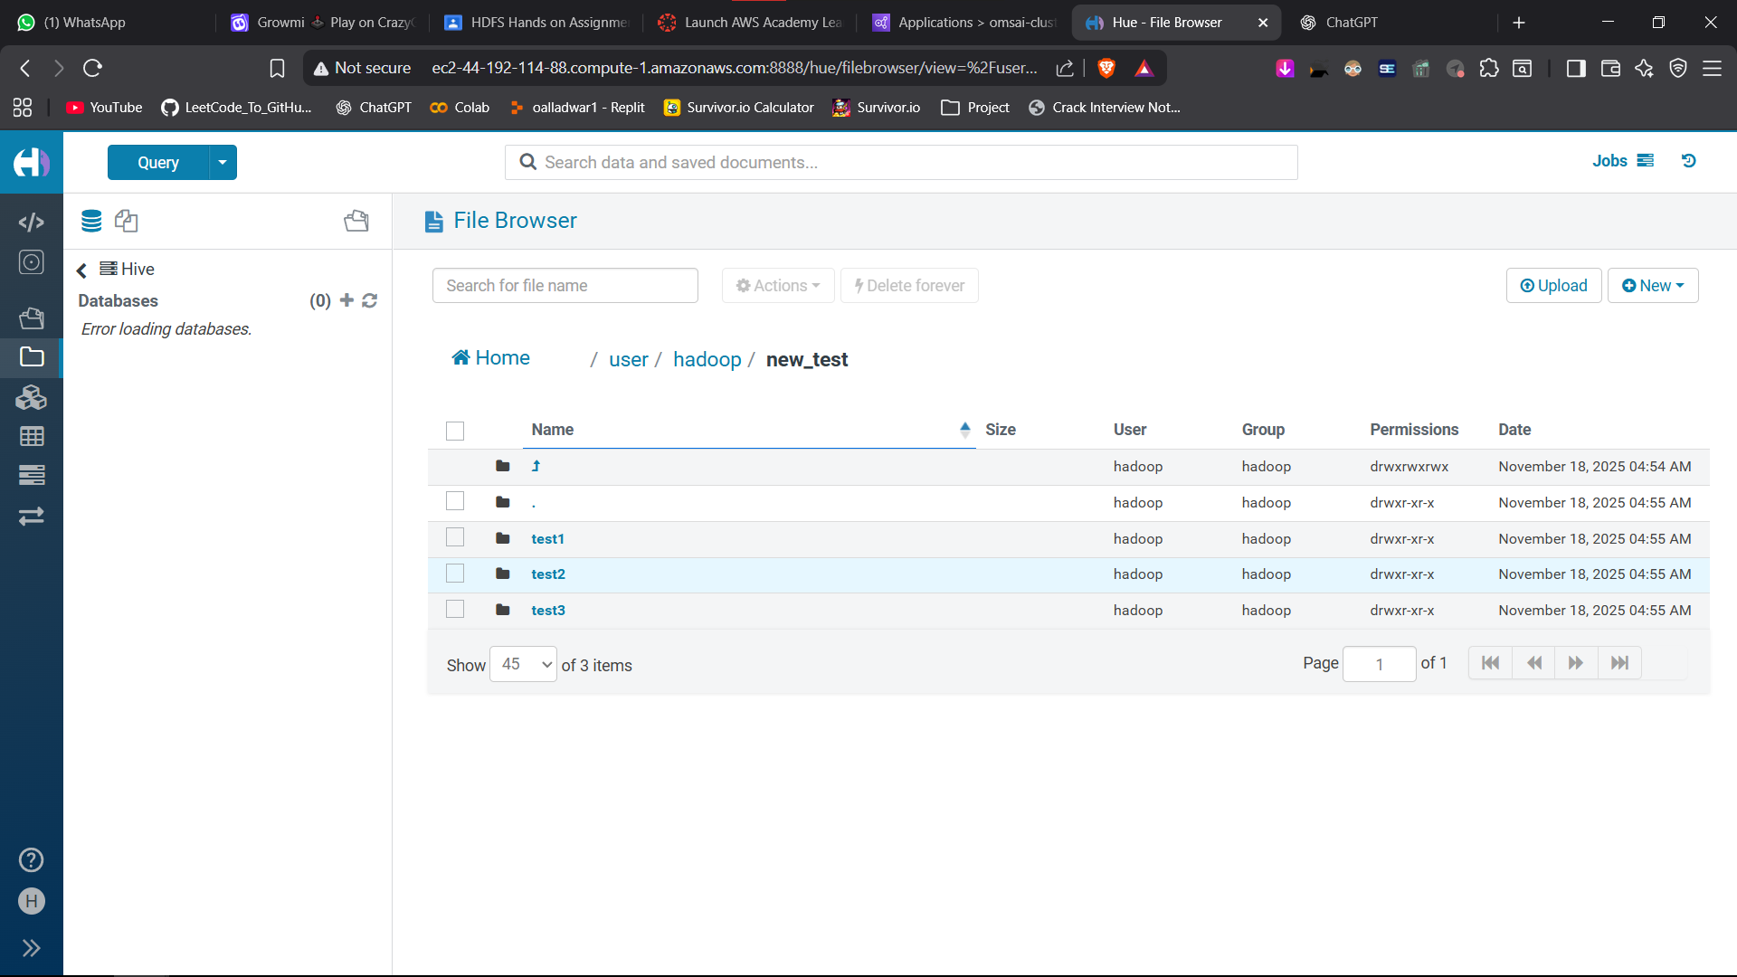

Copied sample.txt from test folder to new_test/ test1, test2,test3 folders
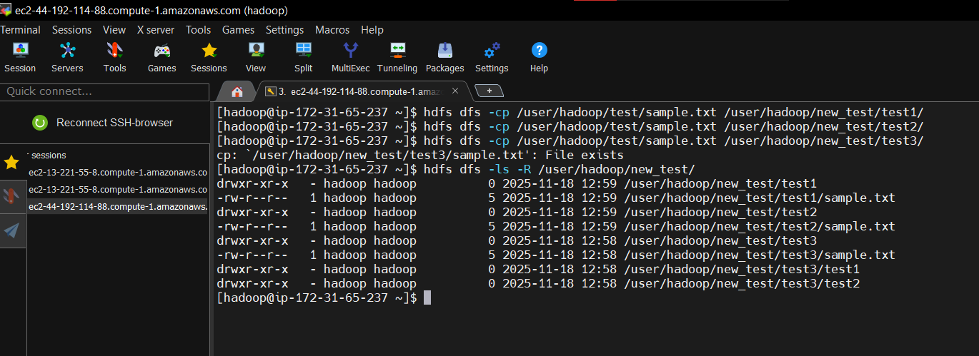

Deleted test, new_test, test1,test2,test3 folders along with sample.txt and all the copies.
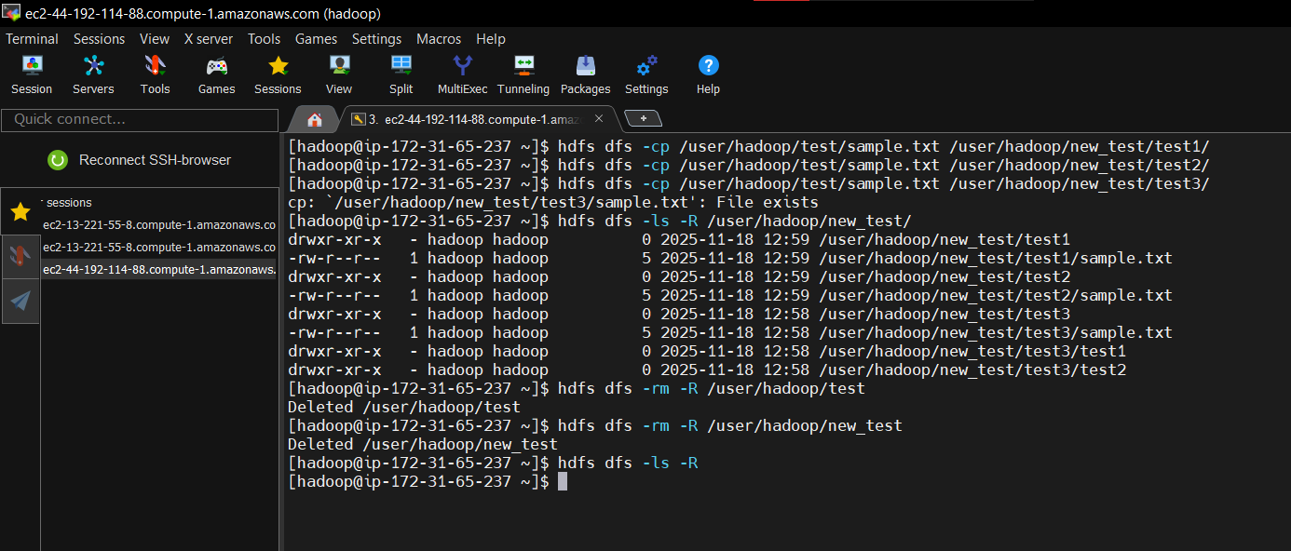

Clean Home directory of Hue
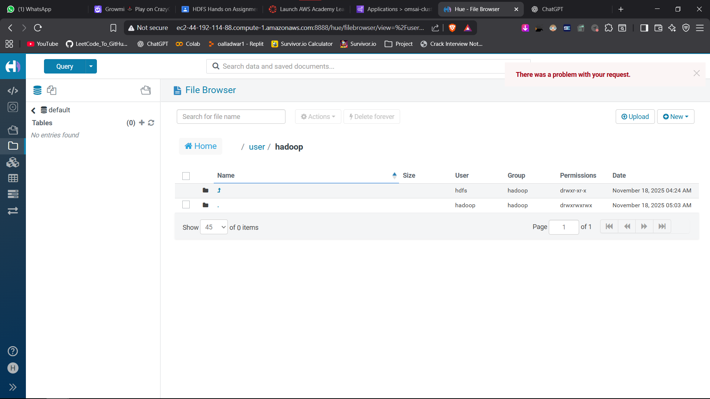

ssh -i traya-key-us-east-1.pem hadoop@ec2-44-192-114-88.compute-1.amazonaws.com

hostname

